

**Placement Empowerment Program**

***Cloud Computing and DevOps Centre***

**Use Cloud CLI Tools:** Install the CLI for your cloud provider (e.g., AWS CLI). Use it to list resources, upload files to storage, and manage VMs.

**Name: VIJAYA NANDANA M Department : CSE**

**Introduction**

Cloud CLI tools, such as AWS CLI, allow users to interact with cloud services directly from the terminal, enabling automation and efficient resource management. This task involves installing the AWS CLI, configuring it with AWS credentials, and using it to perform basic operations like listing resources, uploading files to S3, and managing EC2 instances. CLI tools offer a faster and scriptable alternative to the AWS Management Console, improving productivity. By completing this task, you 'll gain hands-on experience in cloud automation and resource control using command-line commands.

**Objectives**

* Learn Cloud CLI Basics – Install and configure AWS CLI to interact with cloud resources using command-line commands.
* Manage Cloud Resources – Use AWS CLI to list cloud resources, upload files to S3, and manage EC2 instances efficiently.
* Enhance Automation Skills – Gain hands-on experience in automating cloud tasks, improving efficiency over manual AWS Management Console operations.

**Step by Step Overview**

**1. Search CLI installer for windows**

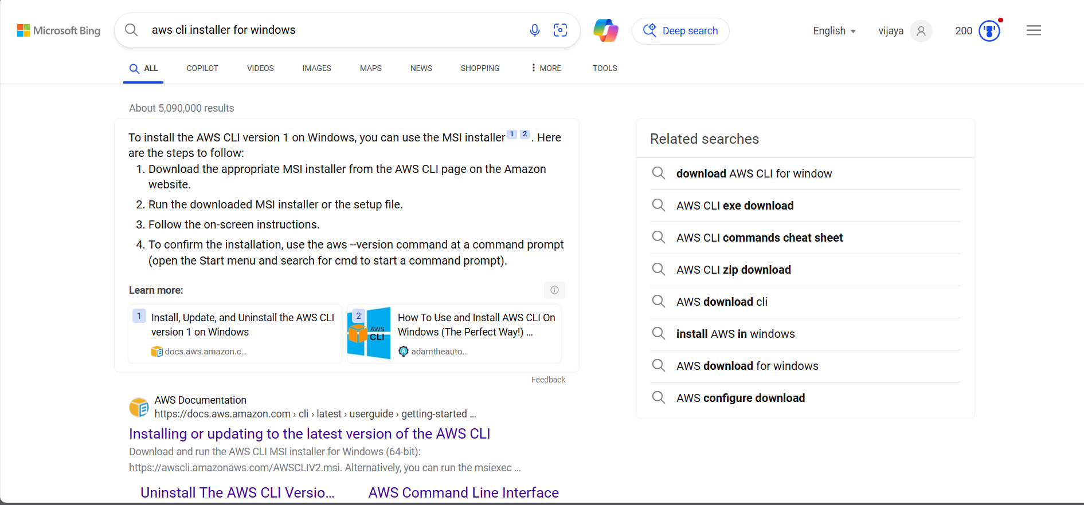

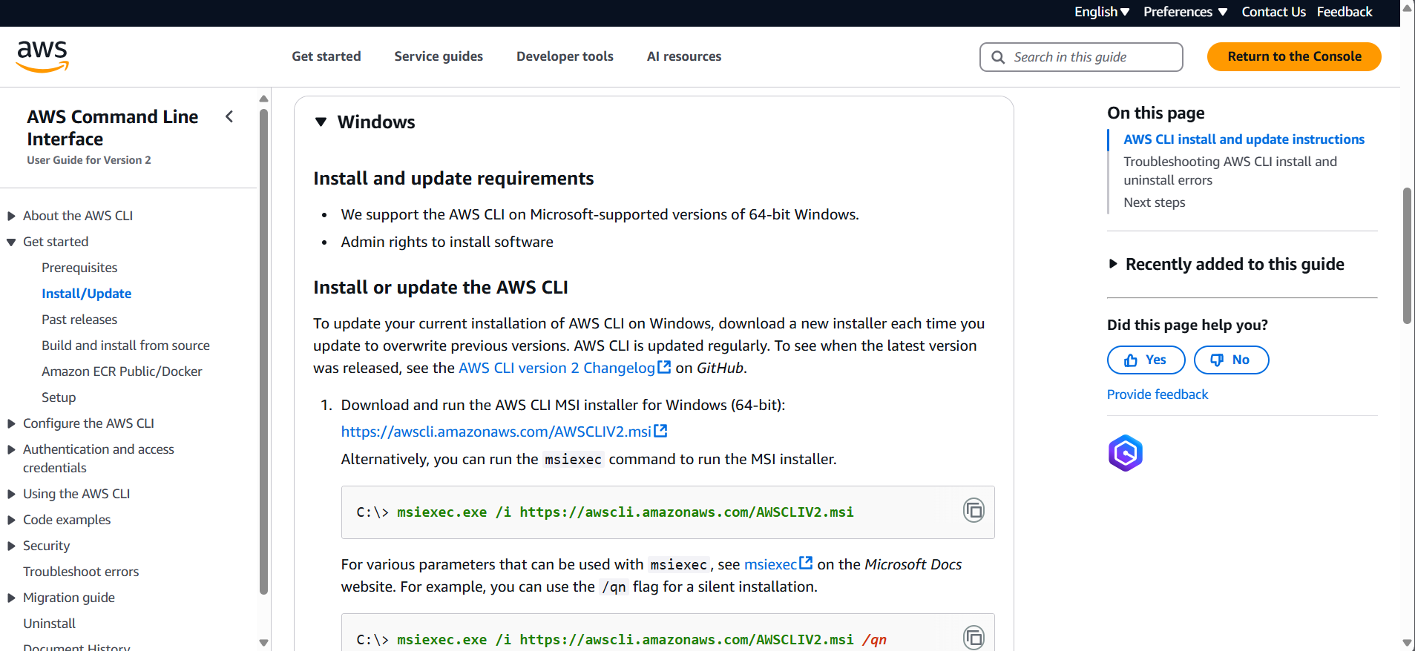

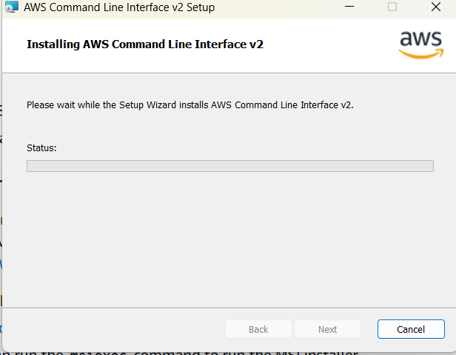

**2. Once installed, verify the installation**

By opening Command Prompt type **aws –version.**



### **3. Configure your account**

Before using AWS CLI, you need to configure it with your AWS credentials. Open Command Prompt and type **aws configure**.



It will ask for the following : (get these from your IAM access credentials)

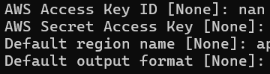

**4. Check your EC2 instances available**

Type **“ aws ec2 describe-instances”** to check the instances.

Similarly you can get the list about list of s3 buckets you have by typing **“aws s3 ls”.**

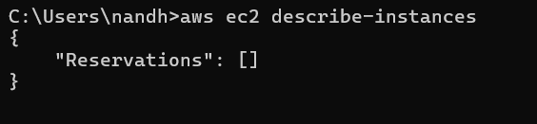

**5. Create Bucket**

Create a new bucket using **“ aws s3 mb s3://your-bucket-name ”** command.

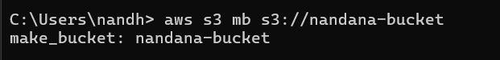

Upload into the s3 bucket using the below command.



**6. Check the console**

Log in to your console and check the s3 service. You can find the bucket and file you uploaded through CLI in it.

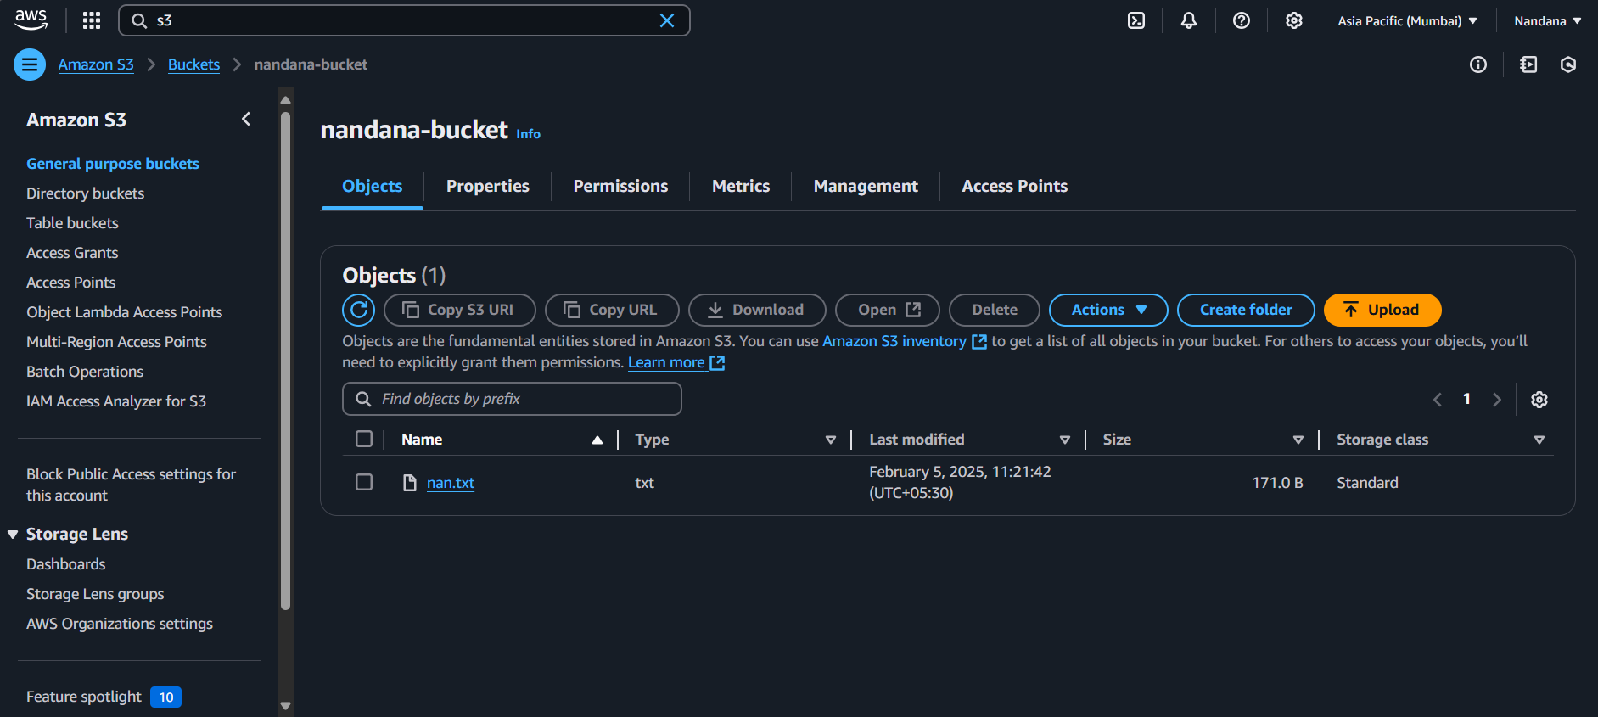

**7. Deleting the bucket**

First, empty the bucket using **“aws s3 rm s3://your-bucket-name –recursive”**

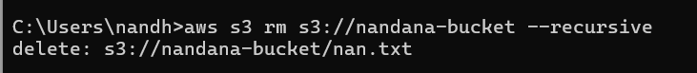

Now, delete the bucket using **“aws s3 rb s3://your-bucket-name”**

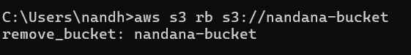

**8. Starting an EC2 instance**

To Start an EC2 Instance, Type **aws ec2 start-instances --instance-ids** in cmd.

Replace with your actual instance ID.

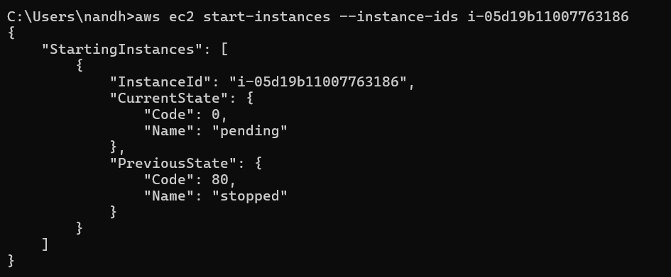

**Outcome:**

* **Successful Installation & Configuration** – AWS CLI will be installed and configured with the correct credentials, allowing seamless interaction with AWS services.
* **Ability to List Cloud Resources** – You will be able to list AWS resources such as S3 buckets, EC2 instances, and IAM users using CLI commands.
* **File Management in S3** – You will gain hands-on experience in uploading, downloading, and managing files in Amazon S3 using the CLI.
* **EC2 Instance Control –** You will learn how to start, stop, and reboot EC2 instances from the command line, improving your cloud management skills.